**E-MAIL ID:** vidyashreesv1999@gmail.com 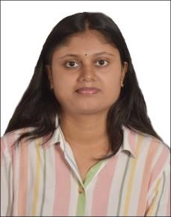

**VIDYAHREE SV**

# MOBILE NO: 7996920665

**CAREER OBJECTIVE:**

Seeking excellence in the professional field through positive attitude, hard work and commitment towards the organization where knowledge has always been the top priority to cope up with the future challenges, skills are suitably rewarded and given chances to constantly add value to the company at large by working at the cutting edge of technology.

**TECHNICAL SKILLS AND SUMMARY:**

**1. CORE JAVA**

* **Create** classes and objects and add methods to a class.
* Excellent in Inheritance and Polymorphism.
* Strong in Type Casting and Encapsulation.
* Sound knowledge in Abstraction.
* Very good in Collection Frameworks.
* Implement error handling techniques using Exception Handling.
* Learnt and implemented java Threads.
* Very good in programming/coding in edit plus and Eclipse.
* Knowledge of java Bean and Singleton class.

1. **WEB TECHNOLOGY** 
   * HTML5
   * CSS3
   * JAVASCRIPT

**SOFTWARE EXPOSER:**

JDK 1.8, EDIT plus, Eclipse.

**ACADEMIC PROJECTS:**

* + **“Intelligent Facial Emotion Based Music Player”**

**EDUCATION DETAILS:**

* + - BE in **Electronics and Communication** from Government Engineering college, K R Pet, Mandya in 2020 (**6.1 CGPA**).
    - Diploma from Government Polytechnic College, Nagamangala in 2017. (**69%**)
    - S.S.L.C from Priyadarshini High School, K R Pet, Mandya in 2014(**72.48%)**

**PERSONAL DETAILS:**

|  |  |
| --- | --- |
| Name | : Vidyashree SV |
| Father Name | : Venkatesh SR |
| Mother Name | : Geetha |
| Date of Birth | : 30-01-1999 |
| Languages | : English, Kannada. |
| Hobbies | : Cooking, Cycling, and Walking. |
| Permanent Address | : Satenahalli, Bindiganavile, Nagamangala(T), Mandya(D), Karnataka – 5710802. |

**DECLARATION:**

I hereby declare that all the information provided is true to the best of my knowledge and belief.

Date: Vidyashree S V Place: